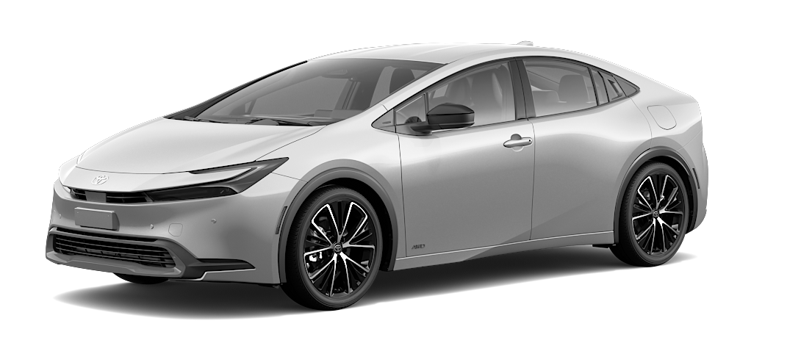
Prius
Hybrid Fuel Source

Do you feel that purchasing this car will improve or hurt your social status among your friends and family?

1 Hurt a lot
2 Hurt somewhat
3 Neutral
4 Improve somewhat
5 Improve a lot

Does the car’s design deviate from your previous expectations of what a Toyota should look like?

1 A lot, in a bad way
2 A little bit, in a bad way
3 Not at all
4 A little bit, in a good way
5 A lot, in a good way

Do you feel that the fuel source is consistent with the values or policies your preferred political party?

1 Definitely no
2 Somewhat no
3 Neutral
4 Somewhat yes
5 Definitely yes

